Module 2 Lesson 5:

Solving Polynomials of Higher Degrees

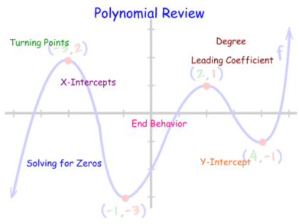

Learning Targets:

I can use polynomial reverse tabular and synthetic division to find the solutions of a polynomial function.

I can find all of the solutions of higher degree polynomial functions algebraically.

I can sketch the graphs of polynomial functions using the roots, y-intercept, and end behavior.

Sketch the graph of $x^{3}-3x^{2}-25x+75=0$.

Roots:

y-int:

End Behavior:

Can we approach sketching $P\left(x\right)=2x^{3}+{3x}^{2}-23x-12$ the same way? Explain:

What if you are told that (x – 3) is a factor of $P\left(x\right)=2x^{3}+{3x}^{2}-23x-12$. Find the remaining roots, find the y-intercept, and state the behavior.

***Example 2***: Find the all of the solutions of the polynomial function $P\left(x\right)=-2x^{3}+7x^{2}-4x-4$ provided that $(x – 2)$ is a factor.

***Example 3:*** Find all of the solutions to the polynomial $P\left(x\right)=x^{4}+3x^{3}-13x^{2}-51x-36$ provided that x = -3 is a root with a multiplicity of 2.

***Example 4:*** Given the polynomial $P\left(x\right)=x^{4}-5x^{3}+3x^{2}-45x-54$

1. Write the polynomial in factored form, provided that $x – 6$ is a factor of $P(x).$
2. State all of the solutions of $P(x).$
3. State the end behavior of the polynomial.
4. Sketch the function.

HW/Practice:

Find all of the solutions to each of the following polynomials and sketch the graph.

|  |  |
| --- | --- |
| $$x^{4}-13x^{2}+36=0$$ |  |
| $$8x^{3}+4x^{2}-18x-9=0$$ |  |
| $$x^{3}+6x^{2}-4x-24=0$$ |  |

Find the solutions to each of the following polynomials.

|  |
| --- |
| $P\left(x\right)=x^{3}-7x+6$ given $(x+3)$ is a factor. |
| $P\left(x\right)=x^{3}-2x^{2}-20x-24$ given $x = -2$ is a root. |
| $P\left(x\right)=-x^{3}+4x^{2}-x-6$ given $(x + 1)$ is a factor. |